Fog and Scan Post Processing effect

## Overview

This is a post-processing effect. There are two effects in this shader one that look like mist or fog and one that looks like it's scanning in the nighttime.

## Software Requirement

* Needs a computer that can successfully run the Unity engine. Use 2021 version of Unity if Possible
* Use VScode or Visual studio to code and update programs if needed.

## The idea behind the effect

The basic idea behind the effect is to create a strip that can move. So, we needed a starting point for the front half and then we need an endpoint that will have a strip and we can just use a time from unity to move it around.

For calculation of front, it uses the depth seen by the camera and the distance (here we add the normal information to incorporate the texture in the effects) from where we want it to project. Based on the front, we canaliculate how thick the strip should look. And then we calculate the area that it will cover. Then, we use the outline effect (created by Professor Aron Lanterman) to give it a night vision-type look to the scene. After that, we use lerp to toggle between the original color and color of the strip to look like it is scanning the area.

The side effect of this was to make distance steady and tweak the calculation of the front we get the pillar instead of a 2d strip. Which if we lerp between the original and the pillar color we get this early morning fog-like effect where we can see stuff ahead of the camera but not so far ahead of the camera

# How to use this Effect

To try out this effect, one must import the unity package and then load the scene, and then hit play. After that click on the main camera in the Hierarchy, go all the way bottom in the inspector, where you can find the Fog and Scan Stack in post-process Volume. Use the dropdown to use other settings like Color thickness and which effect you want to see. If you want to see Fog then click on the Active Fog (you have to raise the thickness value to see it properly) otherwise it will run a scan effect.

Here are some recommended settings for both effects:

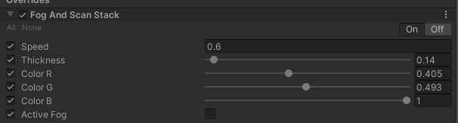

Figure 1 This is recommended the setting for scan effects.

* The output of the above setting

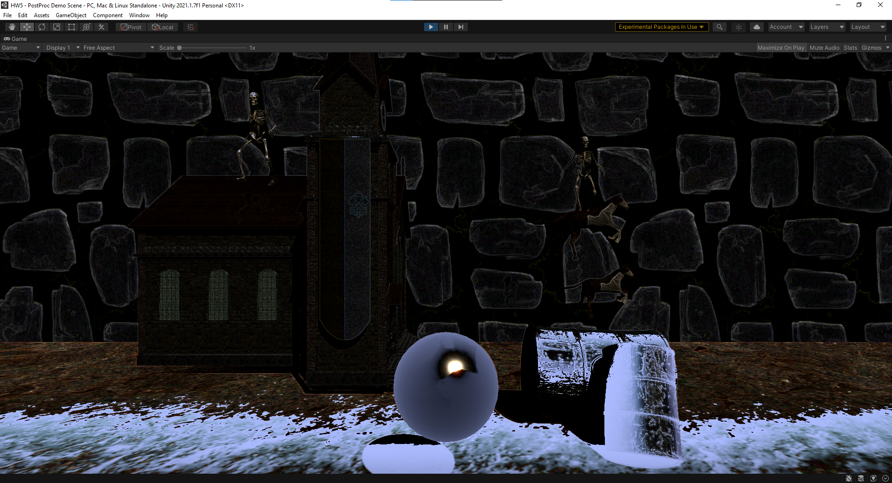

Figure 2 scanning forward

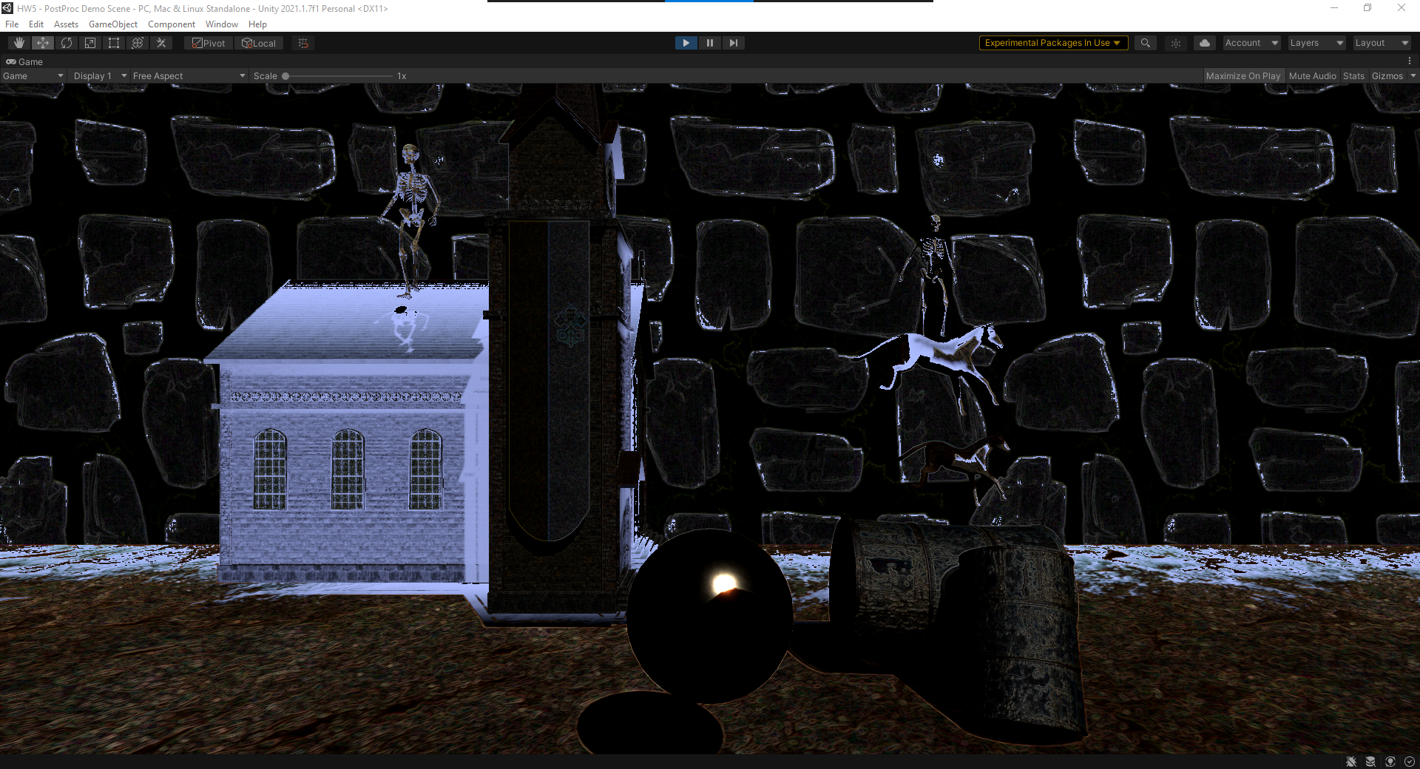

Figure 3 Scanning Coming back

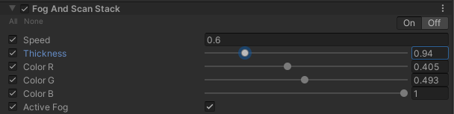

Figure 4This is for the Fog effects

* The output for the fog effects

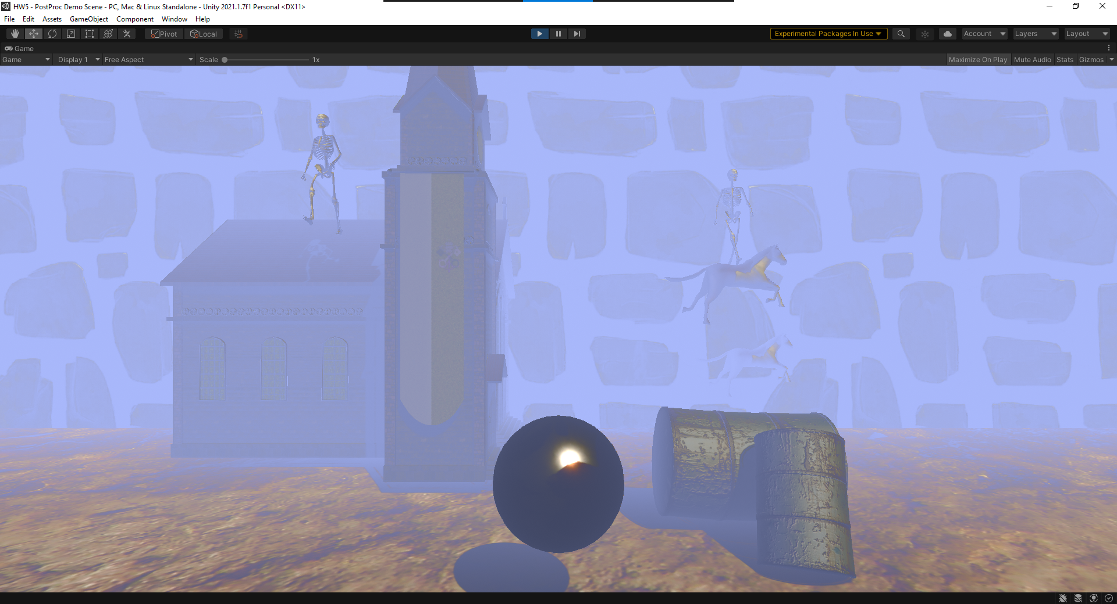

Figure 5 exact setting as above

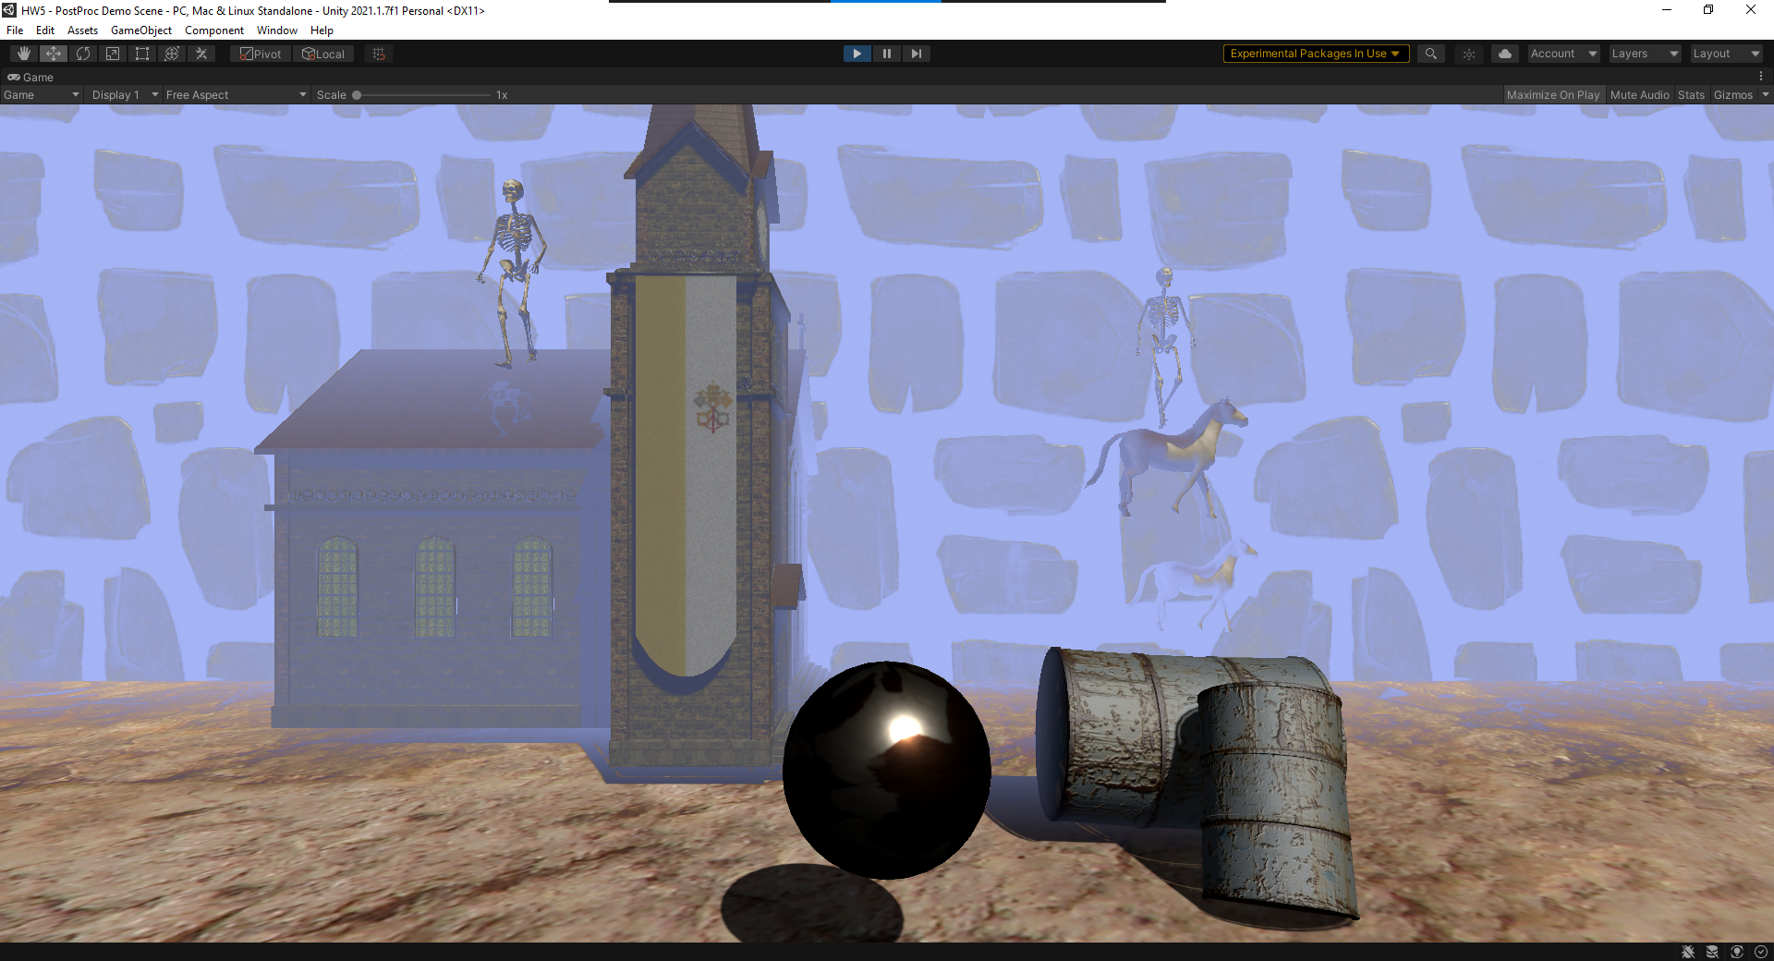

Figure 6 less thick fog